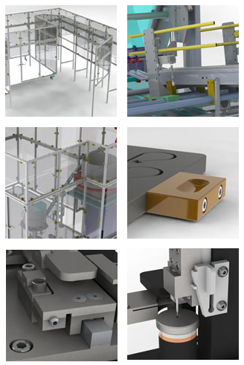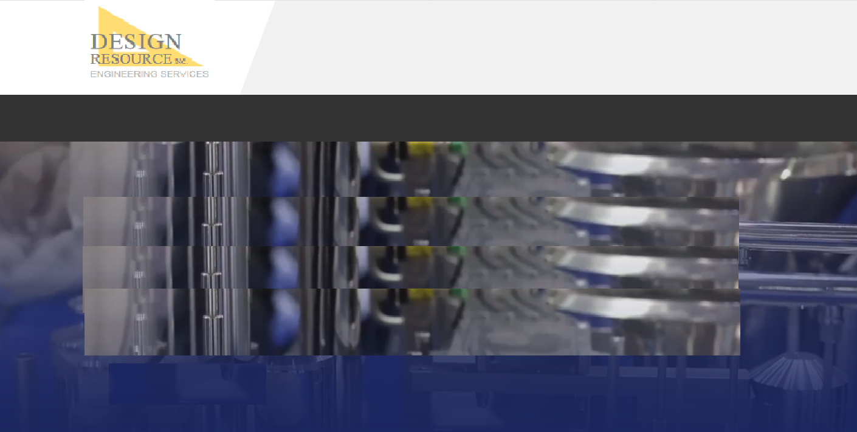

**HOME | ENGINEERING | STAFFING | COMPANY | CONTACT**

**© 2019 DESIGN RESOURCE, INC.**

Can these pics hover to a temporary full, larger image while the mouse is over them?

**Machining and assembly**

* Fast turn around
* Single parts or complete machines
* All materials
* Assembly and wiring
* PLC and motion programming
* Complete inspection
* Full drawings, BOMs, schematics

**Prototyping**

* Proof of concept build
* 3D printed FDM prototypes
* 3D printed SLA prototypes

***Complete build from 3D-print prototyping to full assembly, test, and debug.***

**Prototype and build**

**HOME ENGINEERING STAFFING COMPANY CONTACT**